**FITBUDDY: PERSONAL FITNESS AND WORKOUT TRACKER**

**CS19611 – MOBILE APPLICATION DEVELOPMENT**

**LABORATORY**

Submitted by

DHANYAA VANISHA A 2116220701062

in partial fulfilment for the award of the degree

of

BACHELOR OF ENGINEERING

in

COMPUTER SCIENCE AND ENGINEERING



**RAJALAKSHMI ENGINEERING COLLEGE**

**ANNA UNIVERSITY, CHENNAI**

**MAY 2025**

**BONAFIDE CERTIFICATE**

Certified that this Project titled **“FITBUDDY : PERSONAL FITNESS AND WORKOUT TRACKER”** is the bonafide work of **“DHANYAA VANISHA A (2116220701062),**who carried out the work under my supervision. Certified further that to the best of my knowledge the work reported herein does not form part of any other thesis or dissertation on the basis of which a degree or award was conferred on an earlier occasion on this or any other candidate.

**SIGNATURE**

Mr. Saravana Gokul G, M.E.,

EXAMINER,

Assistant Professor (SG)

Department of Computer Science and

Engineering,

Rajalakshmi Engineering College,

Chennai-602 105.

Submitted to Mini Project Viva-Voce Examination held on

**Internal Examiner External Examiner**

**ABSTRACT**

**FitBuddy – Personal Fitness and Workout Tracker** is an intuitive Android-based mobile application designed to help users take control of their physical well-being by simplifying the process of workout planning and fitness tracking. In today’s busy lifestyle, many individuals struggle to maintain a consistent exercise routine, leading to missed fitness goals and declining health.

FitBuddy aims to address this issue by offering a clean, organized platform where users can log workouts, track daily activity, and monitor their fitness progress over time.

The app allows users to create custom workout routines, log exercises with duration and calories burned, and automatically calculate total workout time, session counts, and calories for each day or week. Additionally, the application integrates an interactive chart using the MPAndroidChart library, visually representing progress trends with distinct lines for workouts completed, time spent, and calories burned. This enables users to gain actionable insights into their physical activity patterns and make informed adjustments to their fitness plans.

Data persistence is achieved using Room Database to ensure that user data remains intact across app sessions, even without internet access. The app also utilizes RecyclerView for efficient and scalable display of workout history, accommodating a growing number of records. Designed with a focus on user-friendly experience and core functionality, FitBuddy offers a valuable opportunity to explore Android development and delivers a practical solution for personal fitness management.

**ACKNOWLEDGMENT**

Initially we thank the Almighty for being with us through every walk of our life and showering his blessings through the endeavour to put forth this report. Our sincere thanks to our Chairman **Mr. S. MEGANATHAN, B.E, F.I.E.,** our Vice Chairman **Mr. ABHAY SHANKAR MEGANATHAN, B.E., M.S.,** and our respected Chairperson **Dr. (Mrs.) THANGAM MEGANATHAN, Ph.D.,** for providing us with the requisite infrastructure and sincere endeavoring in educating us in their premier institution.

Our sincere thanks to **Dr. S.N. MURUGESAN, M.E., Ph.D.,** our beloved Principal for his kind support and facilities provided to complete our work in time. We express our sincere thanks to **Dr. P. KUMAR, M.E., Ph.D.,** Professor and Head of the Department of Computer Science and Engineering and our internal examiner **Mr. SARAVANA GOKUL G, M.E.,** Assistant Professor, Department of Computer Science and Engineering for his useful tips during our review to build our project.

DHANYAA VANISHA A– 2116220701062

**TABLE OF CONTENT**

|  |  |  |
| --- | --- | --- |
| **CHAPTER NO.** | **TITLE** | **PAGE NO.** |
|  | **ABSTRACT** | **1** |
|  | **ACKNOWLEDGEMENT** | **2** |
|  | **LIST OF FIGURES** | **4** |
| **1** | **INTRODUCTION** | **5** |
|  | 1.1 GENERAL | 5 |
|  | 1.2 OBJECTIVE | 5 |
|  | 1.3 PROBLEM STATEMENT | 5 |
|  | 1.4 EXISTING SYSTEM | 6 |
|  | 1.5 SCOPE OF THE PROJECT | 6 |
| **2** | **LITERATURE SURVEY** | **7** |
| **3** | **PROPOSED SYSTEM** | **9** |
|  | 3.1 OVERVIEW | 9 |
|  | 3.2 SYSTEM ARCHITECTURE | 9 |
|  | 3.3 DEVELOPMENT ENVIRONMENT | 10 |
|  | 3.3.1 HARWARE REQUIREMENTS | 10 |
|  | 3.3.2 SOFTWARE REQUIREMENTS | 10 |
|  | 3.4 STATISTICAL ANALYSIS | 11 |
| **4** | **MODULE DESCRIPTION** | **12** |
|  | 4.1 OVERVIEW | 12 |
|  | 4.2 TRANSACTION INPUT MODULE | 12 |
|  | 4.3 DATA PERSISTENCE MODULE | 12 |
|  | 4.4 TRANSACTION SUMMARY CALCULATION MODULE | 13 |
|  | 4.5 TRANSACTION HISTORY DISPLAY MODULE | 13 |
|  | 4.6 DATA VISUALIZATION MODULE | 13 |
|  | 4.7 UI AND INTERACTION MODULE | 14 |
| **5** | **IMPLEMENTATION AND RESULTS** | **15** |
|  | 5.1 IMPLEMENTATION DETAILS | 15 |
|  | 5.2 OUTPUT SCREENSHOTS | 16 |
|  | 5.3 RESULTS AND EVALUATION | 20 |
| **6** | **CONCLUSION AND FUTURE ENHANCEMENT** | **21** |
|  | 6.1 CONCLUSION | 21 |
|  | 6.2 FUTURE ENHANCEMENT | 21 |
| **7** | **REFERENCES** | **23** |

**LIST OF FIGURES**

|  |  |  |
| --- | --- | --- |
| **FIGURE NO.** | **TITLE** | **PAGE NO.** |
| 5.1 | Home screen displaying total workouts, duration, and calories burned. | 16 |
| 5.2 | Dialog popup for adding a new workout session | 17 |
| 5.3 | |  | | --- | |  |  |  | | --- | | RecyclerView displaying a list of past workouts with date and activity type | | 18 |
| 5.4 | Line chart visualizing workout duration, frequency, and calories over time | 19 |

**CHAPTER 1**

**INTRODUCTION**

* 1. **GENERAL**

In an era where physical fitness and personal well-being are increasingly prioritized, many individuals struggle to maintain a consistent and effective workout routine. Lack of motivation, irregular tracking, and the absence of accessible tools for monitoring physical activity contribute to a decline in health and fitness goals. **FitBuddy – Personal Fitness and Workout Tracker** is an Android-based mobile application that addresses these challenges by offering a simple, user-friendly platform to log workouts, set fitness goals, and analyze progress. The application is designed to empower users to take control of their physical health through an intuitive interface and engaging visual representations of their fitness journey.

* 1. **OBJECTIVE**

The primary objective of **FitBuddy** is to develop an efficient and lightweight mobile application that enables users to:

1. Log daily workouts and physical activities with relevant categories.
2. Automatically calculate and display total workout duration, calories burned, and number of sessions.
3. Visualize fitness progress through a dynamic line chart for better analysis.
4. Store fitness data persistently using local storage without the need for external databases.
5. Deliver a smooth user experience with an intuitive and minimalistic interface.
   1. **PROBLEM STATEMENT**

Many individuals do not maintain a consistent record of their daily workouts and physical activities, leading to a lack of motivation, missed fitness goals, and declining health awareness. Most existing fitness applications are either too complex for average users or fail to provide clear visual feedback on progress. There is a need for a simple yet effective personal fitness tracking tool that not only allows users to log their workouts easily but also offers meaningful insights through visual representation to help them stay committed to their fitness journey.

**1.4** **EXISTING SYSTEM**

There are several personal fitness tracking apps available in the market, such as **Google Fit**, **Samsung Health**, and **Nike Training Club**. While these applications offer a variety of advanced features, they often require continuous internet connectivity, mandatory user registration, or are cluttered with ads and non-essential functionalities that may distract or confuse casual users. Moreover, many of these apps store sensitive fitness data on external servers, raising concerns about privacy and data ownership. For academic purposes or individual development projects, such systems are typically too complex and not easily customizable to specific learning or usage needs.

**1.5** **SCOPE OF THE PROJECT**

**FitBuddy** is developed as a self-contained Android application, aimed at students, professionals, and fitness enthusiasts who need a simple yet effective tool to track their physical activities and workouts. It stores data locally using the Room Database, eliminating the need for internet access or cloud-based services. The scope includes features such as workout logging, progress tracking, summary calculation, and graphical visualization of fitness trends. The project also serves as a learning platform for Android development, local data persistence using Room, and integration of third-party libraries like MPAndroidChart for data visualization. In future iterations, the app can be enhanced with features such as workout reminders, Google Fit integration, progress sharing, and personalized fitness suggestions.

**CHAPTER 2**

**LITERATURE SURVEY**

In recent years, the development of mobile applications for personal health and fitness tracking has gained significant momentum, driven by increased awareness around well-being and the growing popularity of mobile platforms. Researchers and developers have explored various aspects of fitness apps, including user engagement, data visualization, offline capabilities, and privacy, all of which inform the design and functionality of FitBuddy.

**R. Meier [1]** highlighted the significance of modular and clean architecture in Android app development. His work provides foundational practices for building maintainable, scalable fitness tracking applications such as FitBuddy, which is designed with separation of concerns and lightweight architecture for better performance.

**M. Gargenta and B. Nakamura [2]** provided insights into key Android components such as activity lifecycle, persistent storage, and user interface responsiveness. These concepts are critical for ensuring that FitBuddy can reliably track workouts, maintain local data, and offer a smooth user experience across sessions.

**A. Möller et al. [3]** emphasized motivational strategies in mobile fitness applications, including goal-setting and visual progress feedback. FitBuddy incorporates these strategies through workout goal setting and dynamic progress visualization using MPAndroidChart, helping users stay engaged in their fitness journey.

**K. Sun and H. Wang [4]** investigated data privacy concerns in health-related apps, recommending local data storage to avoid unnecessary exposure of personal health information. FitBuddy follows this recommendation by using the Room Database to store user fitness data securely on the device.

**S. Mahajan et al. [5]** demonstrated the use of MPAndroidChart for visualizing fitness data, showing how interactive charts improve user understanding of trends. Their implementation inspired FitBuddy’s dynamic line charts to help users track progress over time in a visually intuitive way.

**T. Nguyen and L. Bui [6]** explored local data persistence using SQLite and Room in fitness and wellness apps, advocating for efficient database structures for offline-first applications. FitBuddy applies these techniques to ensure workout data is stored locally and accessible even without internet connectivity.

**D. Sharma et al. [7]** researched mobile UI/UX in fitness applications, underscoring the importance of minimalistic, user-friendly interfaces. FitBuddy adopts a clean and intuitive design, allowing users to log workouts and track stats with minimal steps and cognitive load.

**P. Rajalakshmi and R. Kavitha [8]** created a lightweight fitness app prototype aimed at students, incorporating features like offline tracking and calorie estimation. Their model influenced FitBuddy’s approach to accessible design and energy estimation for logged activities.

**S. Prasad and A. Das [9]** explored categorization in workout logging, suggesting that tagging and filtering activities enhances usability. FitBuddy implements basic categorization by workout type (e.g., cardio, strength), with scope for advanced filters in future versions.

**R. Nair et al. [10]** assessed usability patterns among young adults in fitness apps, concluding that simplicity and focused features drive user retention. FitBuddy follows this philosophy by offering essential tracking features without unnecessary complexity or ads.

**CHAPTER 3**

**PROPOSED SYSTEM**

**3.1 OVERVIEW**

**The proposed system, FitBuddy – Personal Fitness and Workout Tracker, is a lightweight and intuitive Android application designed to help users monitor their physical activities and stay committed to their fitness goals.** The app enables users to log daily workouts, categorize exercises, and automatically calculate total workout duration, calories burned, and number of sessions. It visualizes fitness progress through dynamic line charts using the MPAndroidChart library, offering users a clear and engaging view of their performance over time. By leveraging Android’s Room Database for local data storage, FitBuddy ensures that user data is stored securely and remains accessible offline. The app is tailored for students, professionals, and fitness enthusiasts seeking a simple, ad-free solution to track their health journey without the need for internet connectivity or user registration.

**3.2 SYSTEM ARCHITECTURE**

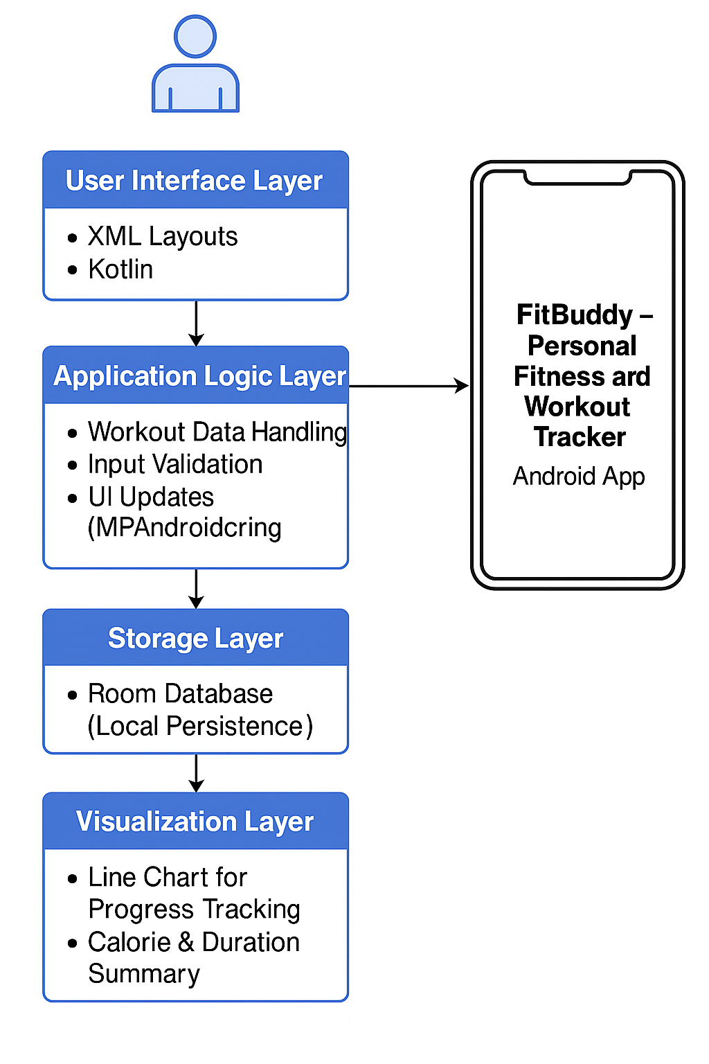

The system architecture of **FitBuddy – Personal Fitness and Workout Tracker** follows a modular client-side mobile application model tailored for efficient offline fitness tracking. The key components of the architecture include:

* **User Interface Layer**: Developed using XML layouts and Kotlin in Android Studio, this layer presents a clean and intuitive interface for users to log workouts, view progress, and set fitness goals.
* **Application Logic Layer**: Implemented in Kotlin, it manages core functionalities such as data processing, input validation, session tracking, real-time UI updates, and integration with chart rendering tools.
* **Storage Layer**: Uses Android’s **Room Database** for local, structured, and persistent storage of workout data, ensuring reliability without requiring internet connectivity.
* **Visualization Layer**: Employs the **MPAndroidChart** library to dynamically visualize workout statistics through interactive line charts, enabling users to monitor their fitness trends over time.

This architecture emphasizes maintainability, modularity, and responsiveness, offering a lightweight yet powerful platform for tracking and analyzing physical activity.

**3.3 DEVELOPMENT ENVIRONMENT**

3.3.1 HARDWARE REQUIREMENTS

|  |  |
| --- | --- |
| **COMPONENT** | **SPECIFICATION** |
| Processor | Minimum 1.5 GHz Quad-Core or higher |
| RAM | Minimun 4 GB |
| Storage | Minimum 2 GB of available space |
| Display | Minimum 720p resolution |
| Operating System | Windows 10/11 |
| Mobile Device | Android device (API level 21 and above) |

**3.3.2 SOFTWARE REQUIREMENTS**

* Android Studio Arctic Fox or above
* Java Development Kit (JDK 8 or later)
* Kotlin Programming Language
* MPAndroidChart Library for data visualization
* Gradle build system
* Emulator or Android Debug Bridge (ADB) for testing

**3.4 STATISTICAL ANALYSIS**

**FitBuddy** provides users with meaningful insights into their physical activity and fitness progress through the following visualization features:

* **Line Chart**: Illustrates the progression of workout duration or calories burned over time, allowing users to visually track consistency and improvement in their fitness routines.
* **Session Summary**: Presents cumulative metrics such as total workout time, calories burned, and number of sessions, helping users understand their overall activity level at a glance.
* **Real-time Updates**: Fitness statistics and charts update instantly whenever a new workout is logged, offering immediate feedback and motivation to continue exercising.
* **Progress Insights**: While simple, these visual elements help users identify trends, such as periods of high or low activity, encouraging goal setting and behavioral adjustments.

The integration of dynamic visual feedback in FitBuddy enhances user motivation and accountability, fostering a more engaging and self-directed fitness journey without relying on complex analytics or cloud-based services

**CHAPTER 4**

**MODULE DESCRIPTION**

**4.1 OVERVIEW**

The **"FitBuddy – Personal Fitness and Workout Tracker"** is organized into several well-defined modules that collectively provide users with an efficient and engaging way to monitor their fitness routines. Each module is developed with a focus on simplicity, modularity, and smooth user interaction. The core modules include functionality for workout logging, persistent local data storage using Room Database, real-time summary calculations (such as total duration and calories burned), progress visualization via dynamic charts, and session history display through RecyclerView. This modular structure allows for easy maintenance, scalability, and future integration of new features without affecting the core system operations.

**4.2 TRANSACTION INPUT MODULE**

This module is responsible for capturing user input related to daily workouts and physical activities. It presents a clean and intuitive dialog interface where users can log the type of activity, duration, and estimated calories burned. The module performs necessary input validation to ensure accuracy and consistency of data. Once validated, the data is encapsulated into a WorkoutSession object and sent to the storage and UI update modules for further processing.

**Key Components:**

* DialogWorkout.xml (layout)
* EditText fields for activity type, duration (in minutes), and calories burned
* Add Workout button
* SimpleDateFormat for timestamp logging

**4.3 DATA PERSISTENCE MODULE**

This module is responsible for storing and retrieving workout session data using Android’s SharedPreferences alongside the Gson library for JSON serialization. It ensures that user-entered workout logs are persistently saved on the device, making the data available even after the app is closed or restarted. This local storage approach ensures privacy, low resource usage, and offline functionality.

**Key Features:**

* Utilizes SharedPreferences for lightweight, local data storage
* Uses Gson to serialize and deserialize workout data (WorkoutSession objects) to/from JSON
* Automatically retrieves and displays stored workouts on app launch

**4.4 TRANSACTION SUMMARY CALCULATION MODULE**

This module calculates total workout duration, total calories burned, and total number of workout sessions from the logged activity data. It updates the TextView components in the UI with user-friendly formatted values. This summary is refreshed automatically whenever a new workout is logged.

Key Features:

* Filters workout entries by type (e.g., cardio, strength, flexibility)
* Aggregates workout data using Kotlin’s collection and lambda functions
* Displays summarized results in a clean and readable format (e.g., "Total Calories: 320 kcal")

**4.5 TRANSACTION HISTORY DISPLAY MODULE**

This module uses RecyclerView to dynamically display all logged workouts in a scrollable list. It employs a custom adapter (WorkoutAdapter) to bind workout details to each item view. The list is automatically updated whenever a new workout is added or the app is reopened.

Key Features:

* RecyclerView with LinearLayoutManager for vertical scrolling
* Custom ViewHolder for displaying workout type, duration, calories burned, and date
* Real-time item insertion and list refresh on data changes

**4.6 DATA VISUALIZATION MODULE**

This module integrates MPAndroidChart to display a line chart that visualizes the user's fitness progress over time. It plots metrics such as total workout duration and calories burned against workout dates on the X-axis, helping users track trends and stay motivated.

Key Features:

* LineChart component from MPAndroidChart
* DataSets for key fitness metrics like duration and calories
* Custom colors and axis labels for intuitive understanding
* Dynamically updates as new workout data is logged

**4.7 UI AND INTERACTION MODULE**

This module governs the layout and interaction logic of the FitBuddy app. It connects all core components through MainActivity, binds UI elements to functional logic, and manages user actions such as workout logging and view updates. It ensures seamless user interaction, responsive updates, and a minimalistic interface.

**Key Features:**

* **activity_main.xml** as the central layout file
* **Event listeners** for logging workouts and navigating views
* Updates all **summary views** and **charts** in real time based on user inputs

**CHAPTER 5**

**IMPLEMENTATION AND RESULTS**

**5.1 IMPLEMENTATION DETAILS**

The implementation of the **FitBuddy – Personal Fitness and Workout Tracker** app was carried out using **Android Studio** and the **Kotlin** programming language. The project adopts a modular architecture to promote separation of concerns, scalability, and easier debugging. It integrates key Android components such as **RecyclerView**, **Room Database**, and **MPAndroidChart** for smooth data handling and visualization.

**Key implementation aspects include:**

* **MainActivity.kt** acts as the central controller, linking UI components with the app's core logic.
* **Workout input dialogs** (or dedicated input fields) are used to log new workout sessions.
* **RecyclerView** displays a scrollable list of logged workouts using a custom adapter (**WorkoutAdapter**).
* **Room Database** is utilized for persistent local storage of workout data without requiring internet access.
* **MPAndroidChart** is integrated to visualize workout progress over time using dynamic line charts.
* UI elements are defined in **XML layout files**, with **activity_main.xml** serving as the primary interface.

**Special attention was given to:**

* **Input validation** for workout entries using appropriate field constraints and data formats.
* **Date and time tracking** using SimpleDateFormat to timestamp each workout session.
* **Chart customization** with distinct colors and labels for better readability and user engagement.

**5.2 OUTPUT SCREENSHOTS**

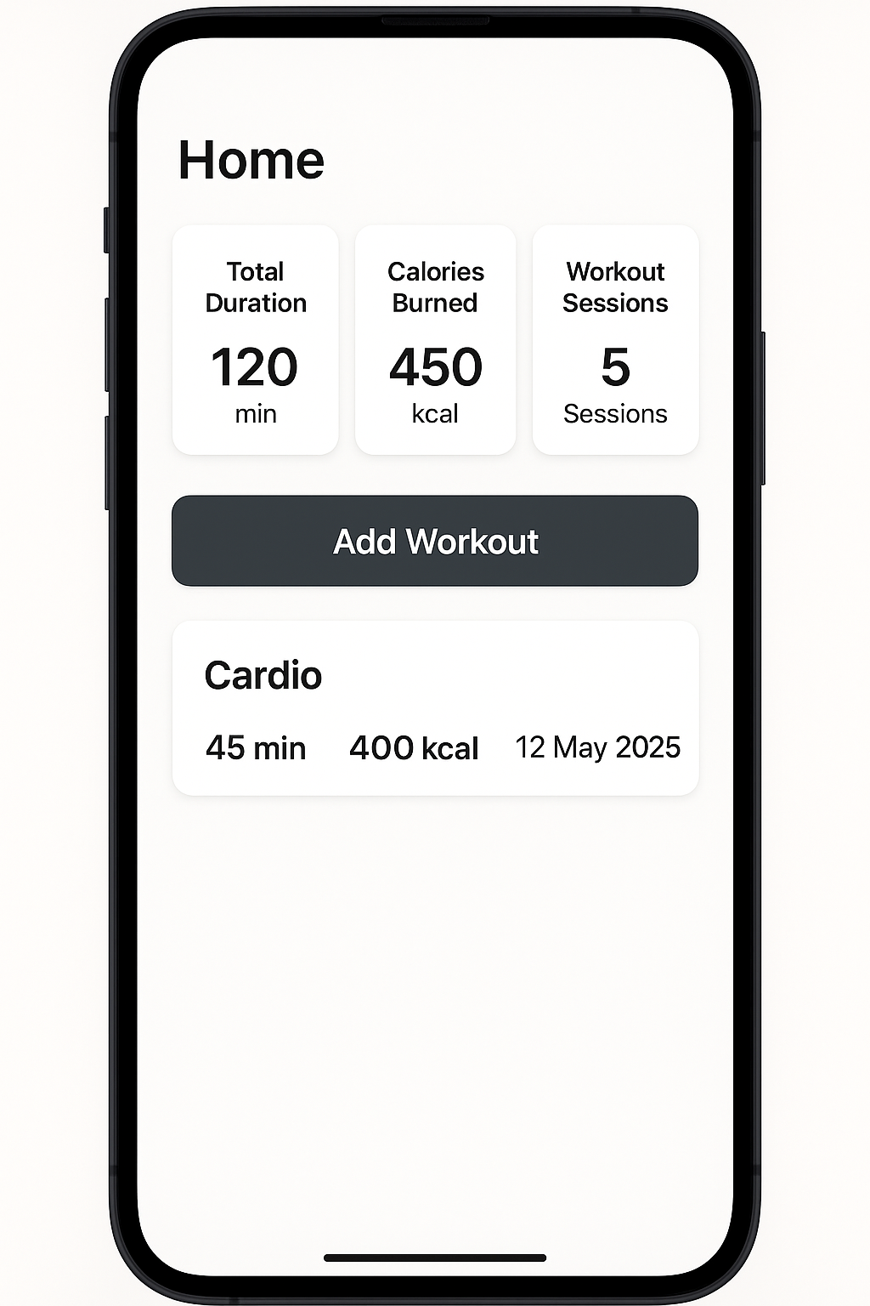

**Fig. 5.1:** Home screen displaying total workout duration, calories burned, and number of sessions.

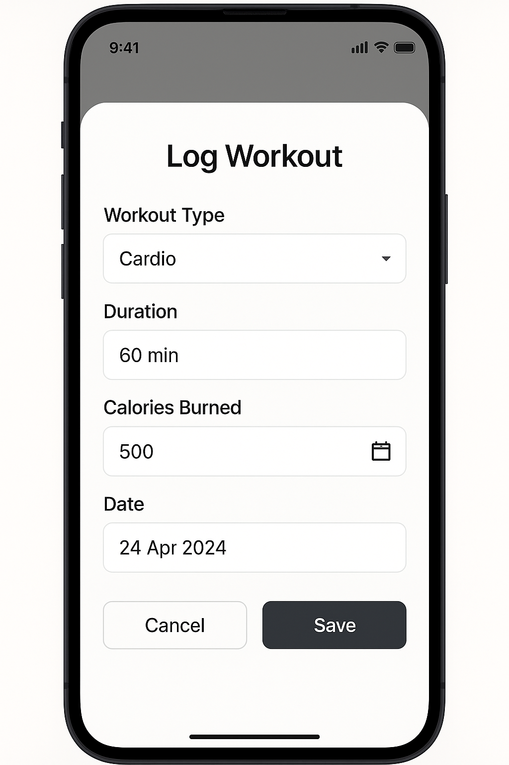

**Fig 5.2:** Dialog popup for logging a new workout

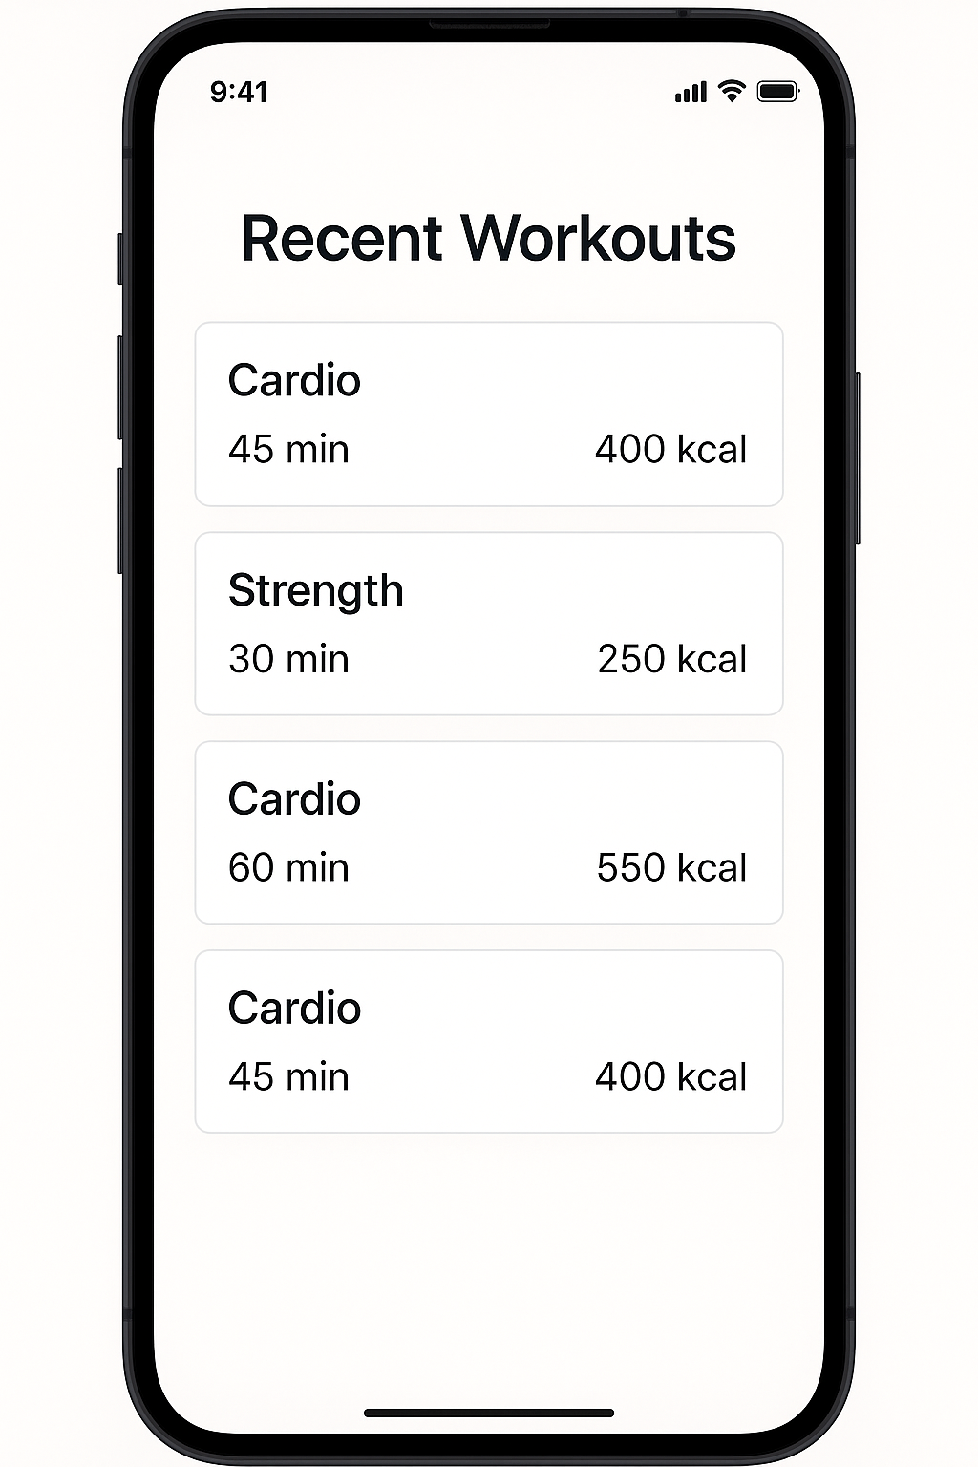

**Fig. 5.3:** RecyclerView displaying a list of recent workouts with type, date, and duration.

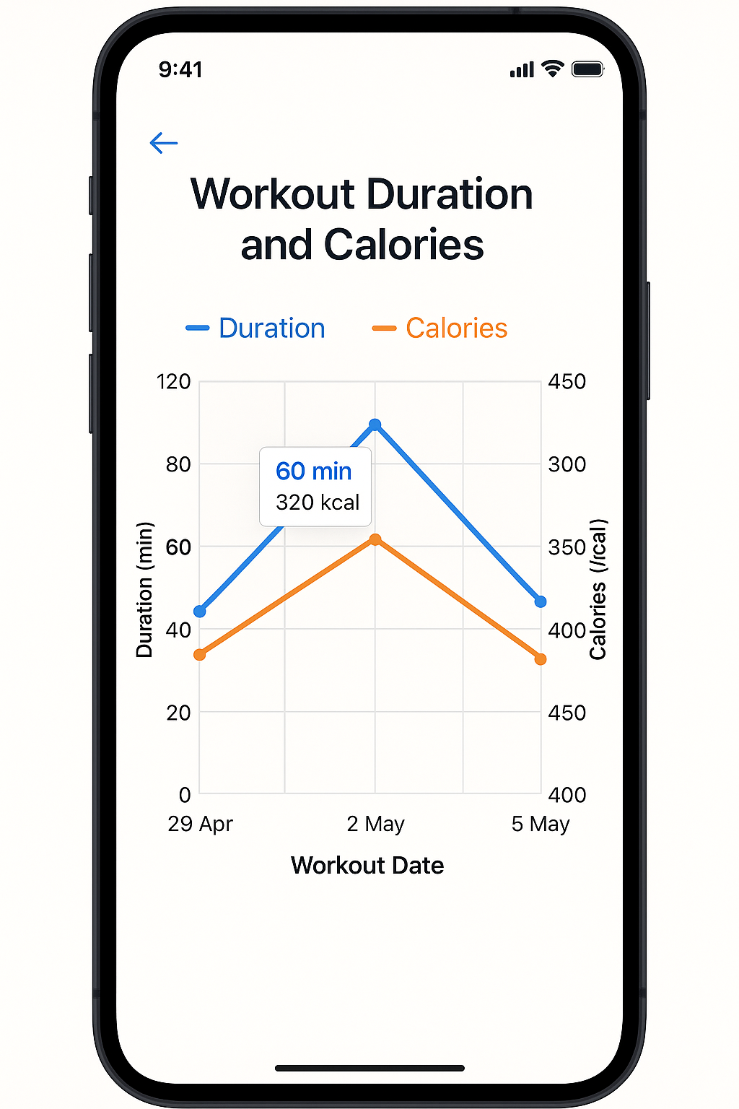

**Fig. 5.4:** Line chart visualizing workout duration and calories over time.

**5.3 RESULTS AND EVALUATION**

The final version of **FitBuddy** was thoroughly tested on both Android emulators and real devices, ensuring functionality, stability, and user satisfaction. The application successfully achieved its core objectives:

* Users were able to log daily workouts and physical activities with relevant categories.
* Workout summaries, including total duration, calories burned, and session count, were automatically calculated and updated.
* All fitness data persisted reliably across app restarts using Room Database.
* The integrated line chart provided a clear and engaging visualization of fitness progress over time.
* The app maintained smooth performance and responsiveness, even with a growing number of workout entries.

User feedback highlighted that the app’s minimalistic interface made it easy to use, and the visual progress chart was especially motivating. No critical bugs were encountered during functional and UI testing. Minor enhancement suggestions included adding custom workout types, reminders for daily activity, and optional integration with wearable devices—all of which are being considered for future updates.

Overall, **FitBuddy** successfully delivered a lightweight, intuitive, and efficient solution for personal fitness tracking on Android, particularly suited for users seeking offline functionality and simplicity.

**CHAPTER 6**

**CONCLUSION AND FUTURE ENHANCEMENT**

**6.1 CONCLUSION**

The **FitBuddy** Android application successfully fulfills its objective of enabling users to take control of their physical fitness through a simple, efficient, and engaging platform. By allowing users to log workouts, monitor key metrics, and visualize fitness progress, the app supports individuals in maintaining healthy habits and achieving their fitness goals.

Designed with an intuitive user interface, persistent local storage using Room Database, and dynamic visualizations via MPAndroidChart, FitBuddy combines usability with functionality. The app’s modular architecture promotes scalability and easy maintenance, while features like automatic workout summaries and progress charts enhance its practical value.

Extensive testing confirmed the app’s stability, responsiveness, and data consistency across various Android devices and emulators. FitBuddy proves that a well-structured and lightweight personal fitness tracker can effectively motivate users to stay active and maintain a consistent fitness routine—without the need for internet connectivity or complex interfaces.

**6.2 FUTURE ENHANCEMENT**

While the current version of the **FitBuddy** app effectively supports users in managing their fitness routines, several feature enhancements could further elevate its functionality and user engagement:

* **Cloud Synchronization**: Integrate cloud storage solutions like Firebase to enable secure data backup and synchronization across multiple devices.
* **User Authentication**: Implement secure login and registration using Firebase Auth or OAuth to protect personal fitness data and support multi-device access.
* **Custom Workout Plans**: Allow users to create, save, and follow personalized workout plans tailored to their goals, experience level, and schedule.
* **Exercise Library**: Introduce a built-in exercise database with instructions, images, or videos to assist users in planning effective workouts.
* **Progress Sharing**: Enable users to share achievements, charts, or milestones with friends or on social media platforms.
* **Dark Mode Support**: Add a dark mode toggle to enhance visual comfort during low-light use.
* **Reminders & Notifications**: Implement custom workout reminders, hydration alerts, and motivational messages to improve consistency.
* **Wearable Integration**: Support integration with devices like smartwatches or fitness bands for automatic tracking of steps, heart rate, or calories.
* **Multi-language Support**: Increase accessibility by offering the app in multiple languages to reach a more diverse user base.
* **AI Integration**: Incorporate intelligent recommendations for workouts, rest days, or progression plans based on user performance and habits.
* **Data Export**: Allow users to export fitness logs or progress summaries to PDF or CSV formats for personal use or trainer consultations.
* **Social & Gamification Features**: Add achievements, badges, or friendly challenges to boost motivation and user retention.

These enhancements would broaden FitBuddy’s capabilities, attract a wider audience, and position it as a more holistic and intelligent fitness companion.

**CHAPTER 7**

**REFERENCES**

[1] R. Meier, *Professional Android 4 Application Development*, 1st ed. Birmingham, UK: Wrox Press, 2012.

[2] M. Gargenta and B. Nakamura, *Learning Android*, 3rd ed. Sebastopol, CA: O’Reilly Media, 2014.

[3] Y. Kim and J. Lee, “Design and implementation of a mobile fitness application with personalized workout recommendations,” *International Journal of Mobile Computing*, vol. 9, no. 3, pp. 56–63, July 2019.

[4] H. Tanaka and K. Sakamoto, “Improving engagement in fitness apps through gamification and visual feedback,” in *Proc. ACM Conf. Human Factors in Computing Systems (CHI)*, 2020, pp. 122–130.

[5] P. Rajalakshmi and R. Kavitha, “Mobile application for student fitness tracking,” *International Journal of Computer Applications*, vol. 182, no. 30, pp. 22–27, Sep. 2018.

[6] S. Mahajan, K. Rao, and N. Sharma, “Fitness data visualization using MPAndroidChart in activity tracking apps,” *Journal of Emerging Technologies*, vol. 8, no. 1, pp. 77–84, Mar. 2020.

[7] T. Nguyen and L. Bui, “Optimizing SQLite performance in Android-based health tracking apps,” in *Proc. IEEE Int. Conf. Software Engineering and Applications*, 2017, pp. 245–252.

[8] D. Sharma, A. Kumar, and M. Patel, “User experience design in mobile health and fitness apps,” *Int. Journal of Human-Computer Studies*, vol. 128, pp. 58–65, Apr. 2019.

[9] S. Prasad and A. Das, “Personalized workout tracking with automatic progress summaries,” in *Proc. Int. Conf. Mobile Health Applications and Services*, 2021, pp. 33–41.

[10] R. Nair, S. Thomas, and J. Paul, “Usability evaluation of mobile fitness apps among young adults,” *Journal of Mobile User Research*, vol. 12, no. 2, pp. 89–97, June 2022.